**Adding new perspective like (OMS or Admin Area):**

1. Create new Widget with in backofficeMainSlot widget extension in **widget.xml**

<widgets xmlns:xsi=*"http://www.w3.org/2001/XMLSchema-instance"*

xsi:noNamespaceSchemaLocation=*"http://www.hybris.com/schema/cockpitng/widgets.xsd"*>

<widget-extension widgetId=*"backofficeMainSlot"*>

<widget id=*"shivaTest-perspective"* widgetDefinitionId=*"hu.vodafone.widgets.vodafonebackofficewidget"* template=*"false"* slotId=*"perspectives"* title=*"Hello vodafonebackoffice"*>

<setting key=*"perspectiveImageUrl"* value=*"/cng/images/perspective.png"*

type=*"String"*/>

</widget>

</widget-extension>

Here

1. *shivaTest-perspective –* is the new perspective
2. widgetDefinitionId – the widget id of respective definition.xml file
3. title – the name of the perspective which is display in backoffice

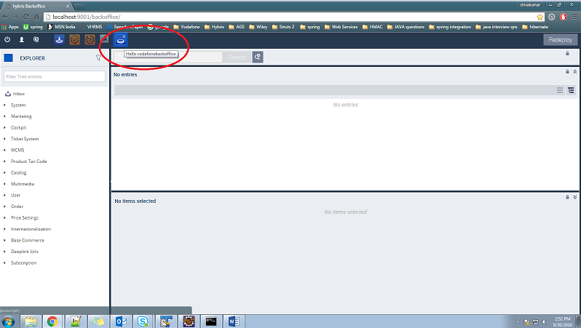

1. create definition.xml for widget

?xml version=*"1.0"* encoding=*"UTF-8"* standalone=*"yes"*?>

<widget-definition xmlns:xsi=*"http://www.w3.org/2001/XMLSchema-instance"*

xsi:noNamespaceSchemaLocation=[*http://www.hybris.com/schema/cockpitng/widget-definition.xsd*](http://www.hybris.com/schema/cockpitng/widget-definition.xsd) id=*"hu.vodafone.widgets.vodafonebackofficewidget"*>

<name>vodafonebackoffice Sample Widget</name>

<description>vodafonebackoffice Sample Widget</description>

<defaultTitle>vodafonebackoffice Sample Widget</defaultTitle>

<author>Extgen</author>

<version>1.0</version>

<view src=*"vodafonebackofficewidget.zul"* />

<keywords>

<keyword>vodafonebackoffice</keyword>

</keywords>

<controller class=*"hu.vodafone.widgets.VodafonebackofficeController"* />

</widget-definition>

Here

1. id=*"hu.vodafone.widgets.vodafonebackofficewidget"*> = the widget id form the widget in widget.xml
2. <view src=*"vodafonebackofficewidget.zul"* /> = the source file name. with this file we can create ui using ZK Framework
3. <controller class=*"hu.vodafone.widgets.VodafonebackofficeController"* /> = the is the class to write the custom logic
4. Zul file of respective definition.xml

<?xml version=*"1.0"* encoding=*"UTF-8"*?>

<widget xmlns=*"http://www.zkoss.org/2005/zul"*

xmlns:xsi=*"http://www.w3.org/2001/XMLSchema-instance"*

xmlns:h=*"http://www.w3.org/1999/xhtml"*

xmlns:w=*"http://www.zkoss.org/2005/zk/client"*

xmlns:zk=*"http://www.zkoss.org/2005/zk"*

xsi:schemaLocation=*"http://www.zkoss.org/2005/zul http://www.hybris.com/schema/cockpitng/zul/zul.xsd"*

height=*"100%"*>

<div height=*"100%"* style=*"background: #ccc;"*>

<div>

<label id=*"label"* value=*"${labels.hello} vodafonebackoffice"* />

</div>

<div>

<image src=*"${wr}/images/headline_icon.png"*/>

</div>

<div>

<label value=*"${labels.hello} vodafonebackoffice"* sclass=*"yw-labelstyle"*/>

</div>

</div>

</widget>

1. Controller class for respective definition.xml

import org.zkoss.zk.ui.Component;

import org.zkoss.zk.ui.select.annotation.WireVariable;

import org.zkoss.zul.Label;

import hu.vodafone.services.VodafonebackofficeService;

import com.hybris.cockpitng.util.DefaultWidgetController;

public class VodafonebackofficeController extends DefaultWidgetController

{

private static final long serialVersionUID = 1L;

private Label label;

@WireVariable

private VodafonebackofficeService vodafonebackofficeService;

@Override

public void initialize(final Component comp)

{

super.initialize(comp);

label.setValue(vodafonebackofficeService.getHello() + " VodafonebackofficeController");

}

}

After doing this all configuration you will find the UI in BackOffice like below screenshot

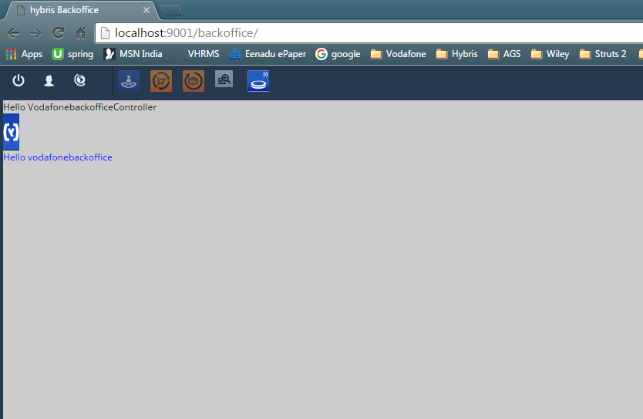

**Till now we have done new perspective creation now we will see extending the existing perspective and customize with our requirement.**

Please refer other document with name **Customizing Existing OMS perspective**